1. Accounting is the process of *identifying, measuring, recording, and communicating* economic events.

2. Primary accounting standard-setting bodies:

* **International Accounting Standards Board (IASB)**
  + Determines International Financial Reporting Standards (IFRS)
  + Used in more than 150 countries
* **Financial Accounting Standards Board (FASB)** 
  + Determines generally accepted accounting principles (GAAP)
  + Used by most companies in the U.S.

3. IFRS generally uses one of two measurement principles, the **historical cost** principle(or cost principle)or the **fair value** principle.

4. Selection of which principle to follow generally relates to trade-offs between **relevance** and **faithful representation.**

5. Two main assumptions are the **monetary unit assumption** and the **economic entity assumption**.

6. ANALYZE business transactions; JOURNALIZE the transactions; POST to ledger accounts; prepare a TRIAL BALANCE; journalize and post ADJUSTING ENTRIES: deferrals/accruals; ADJUSTED TRIAL BALANCE; prepare FINANCIAL STATEMENTS; journalize and post CLOSING ENTRIES; prepare a POST-CLOSING TRIAL BALANCE

11. **Currency Signs**

* Do not appear in journals or ledgers.
* Typically used only in the trial balance and the financial statements.
* Shown only for the first item and the total in the column.

12. Accrual-Basis Accounting, ~~Cash-Basis Accounting~~;

Revenue Recognition Principle, Expense Recognition Principle

15. Adjusted Trial Balance:

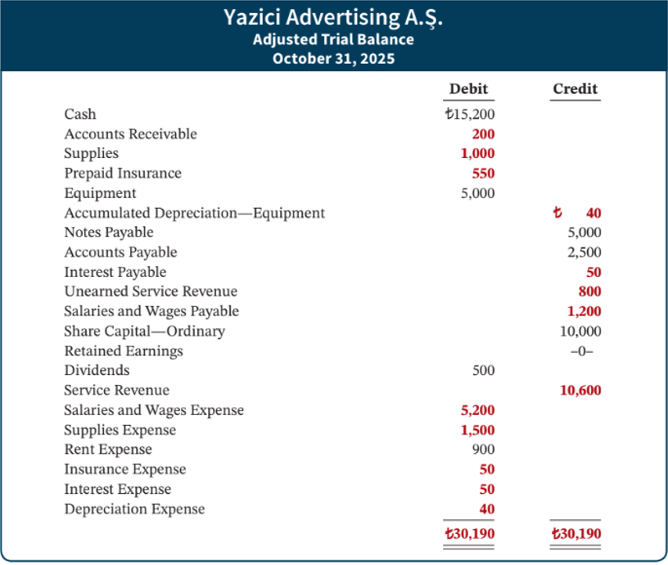

16. Assumptions in Financial Reporting

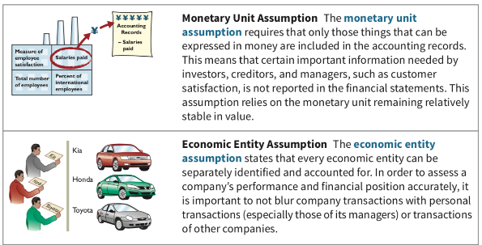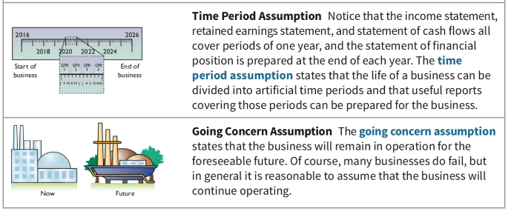

17. Temporary versus permanent accounts

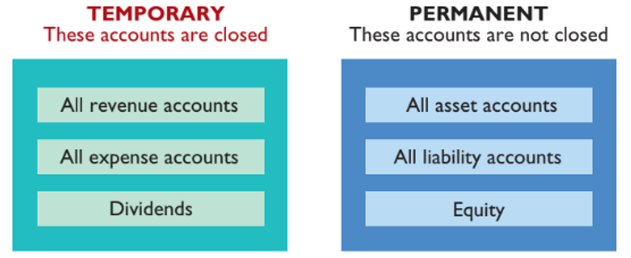

18. Classified Statement of Financial Position

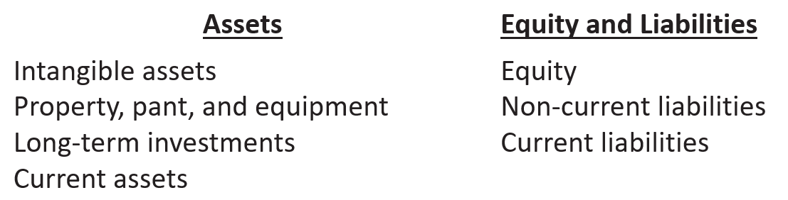

An illustration of a classified statement of financial position. The statement presents a four-line heading consisting of the name of the company, Cheng Limited; the type of statement, Statement of Financial Position; the date at which the statement is prepared, October 31, 2025; and the values in which the statement is prepared, (New Taiwan $ in thousands). This illustration presents the Assets section of the balance sheet, with the label, Assets, centered and shown in bold type, with 4 subsections listed below. There are 4 columns presented, the first presenting account names and the other three presenting the respective amounts and totals. The first asset subsection is labeled as Intangible assets in the first column. Immediately below slightly indented, Patents, is listed, with its respective amount of New Taiwan $3,100 presented in the last numeric column. The second asset subsection is labeled as: Property, plant, and equipment, in the first column. Immediately below with a slight indention appears a list of three accounts with their respective amounts: Land, listed in the second numeric column as New Taiwan $10,000; Equipment, listed as New Taiwan $24,000 in the first numeric column; and Less: Accumulated depreciation, listed as 5,000 in the first numeric column. The accumulated depreciation amount is subtracted from the 24,000 equipment cost, and the difference presented in the second numeric column as 19,000. The cost of the land of 10,000 is added to the net equipment amount of 19,000, and the total is presented in the second of the third numeric column as 29,000. The third asset subsection is labeled as Long-term investments. The following account names are indented slightly in this section, and the respective amounts appear in the second of two numeric columns: Stock investments, 5,200; and Investment in real estate, 2,000. The amounts are totaled as 7,200 which appears in the third numeric column adjacent to the 2,000 amount. The fourth subsection, Current assets, is presented in the first column. The following account names are listed in this section slightly indented with the respective amounts listed in the second of the three numeric columns: Prepaid insurance, 400; Supplies, 2,100; Inventory, 3,000; Notes receivable, 1,000; Accounts receivable, 7,000; Short-term investments, 2,000; and Cash, 6,600. The amounts are totaled as 22,100 which appears in the third numeric column adjacent to the 6,600 amount. Finally, the total of all four subsections is presented in the last numeric column as New Taiwan $61,400 with the label, Total assets, listed in the first column. 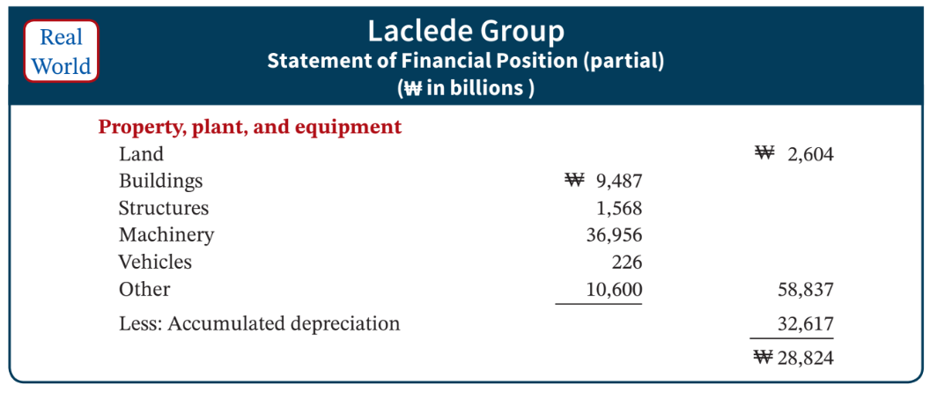 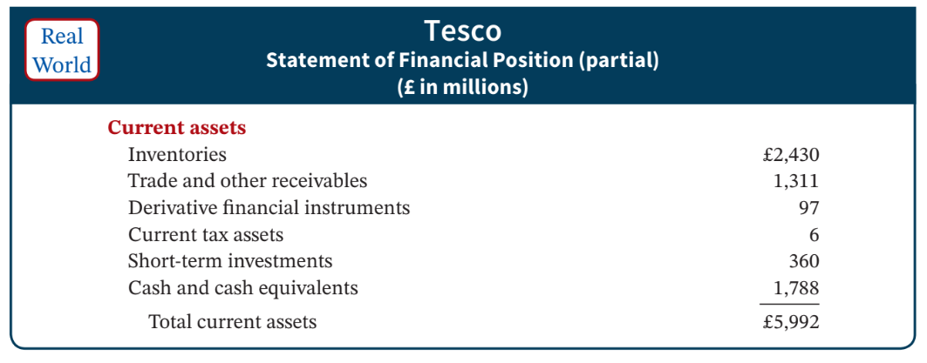

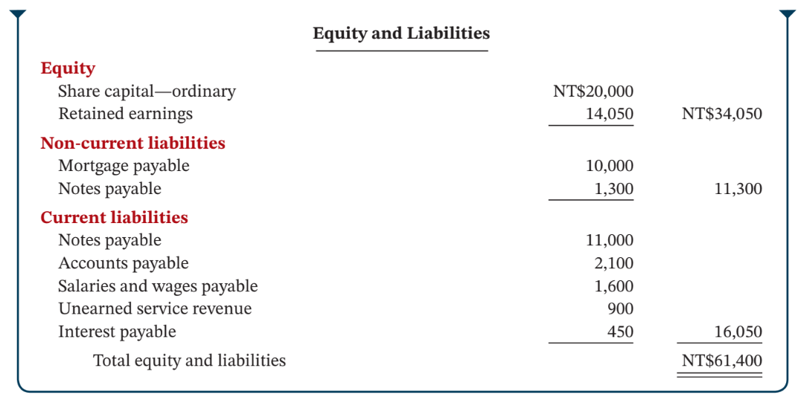

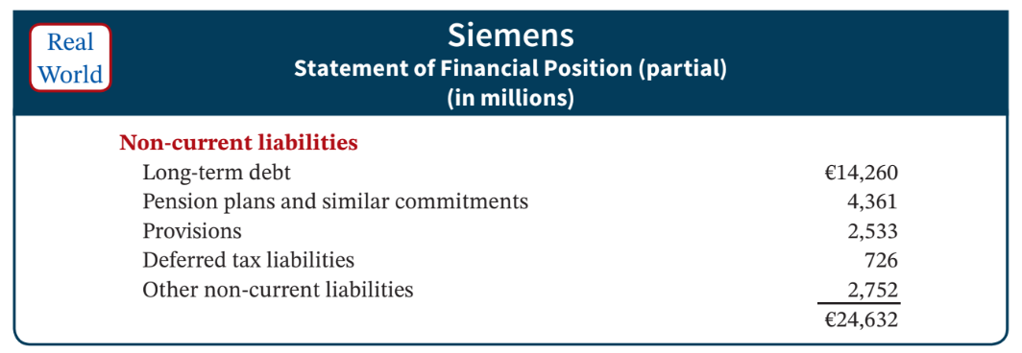 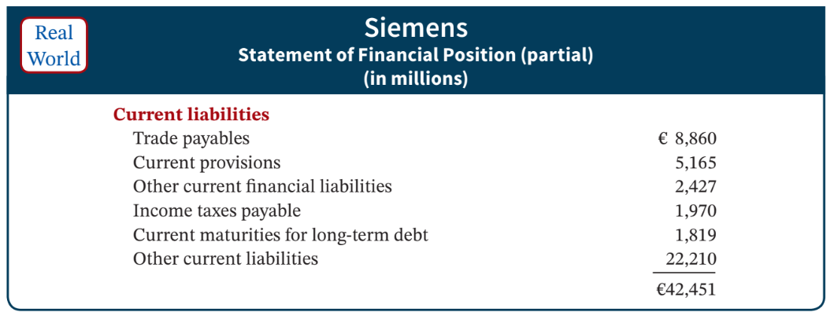

19. **IFRS**

..current asset: in reverse order of liquidity

..adopt broader in fair value

..specific items must be reported on the statement of financial position

..a complete set of financial statements must include comparative information from the preceding period

..often report non-current assets before current assets in their statements of financial position

..PPE can be reported at fair value

..statement of financial position

..a company must make an explicit and unreserved statement that the financial statements comply with IFRS standards

**GAAP**

..current asset: in order of liquidity

..adopt less in fair value

..specific items don’t need to be reported on the statement of financial position

..a complete set of financial statements don’t need to include comparative information from the preceding period

..don’t report non-current assets before current assets in their statements of financial position

..PPE can’t be reported at fair value

..balance sheet

..a company doesn’t need to make such a statement

20. **Flow of costs**

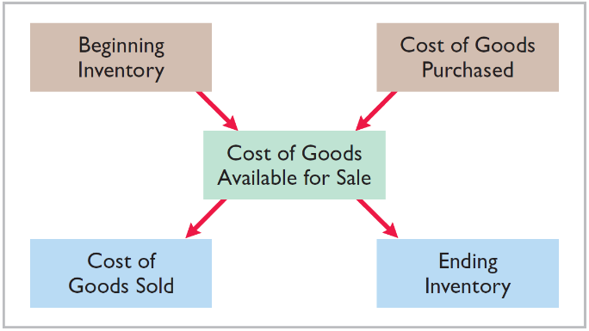

21. **Perpetual System**

- Maintains detailed records of the cost of each inventory purchase and sale.

- Records continuously to show inventory that should be on hand for every item, i.e., directly adjust the inventory account for any transaction that affects inventory (e.g., freight-in, returns, and discounts)

- Company determines cost of goods sold each time a sale occurs.

**Periodic System**

- Companies do not keep detailed records of goods on hand throughout the period.

- Still maintain records of each inventory purchase, but Costs of goods sold determined by count at the period end

- Create different accounts for purchases, freight costs, returns, discounts.

- Calculation of Cost of Goods Sold:

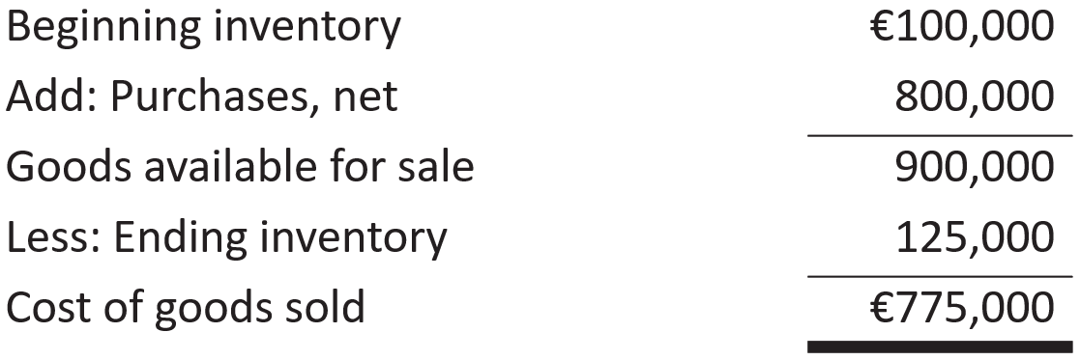

22. **FOB**

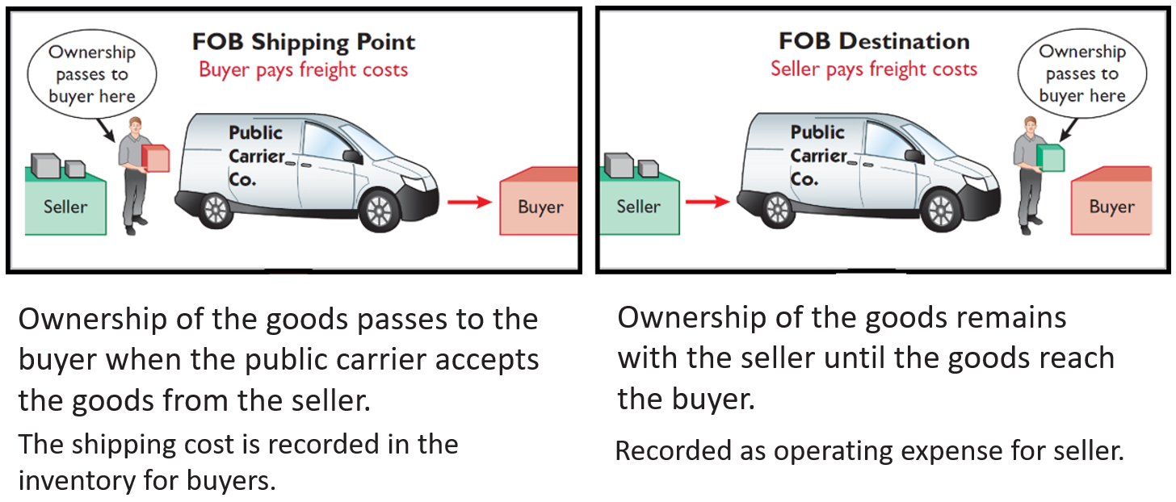



23. **Summary of Merchandising Entries**

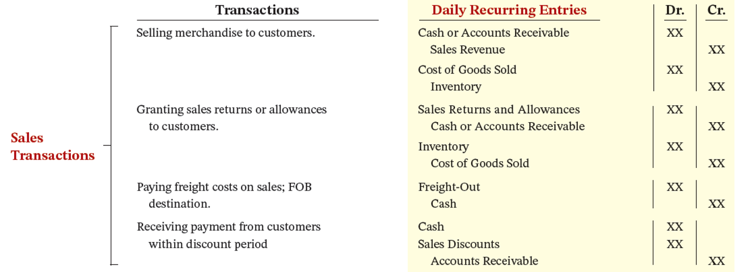 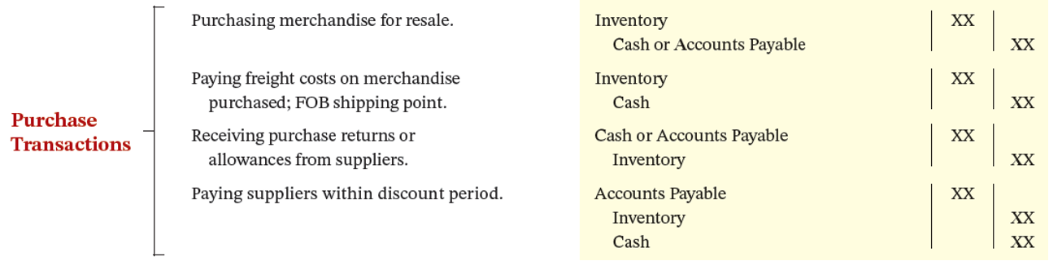



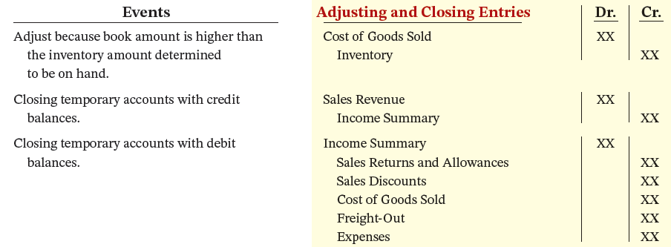

24. Cost of goods sold for a merchandiser using a periodic inventory system

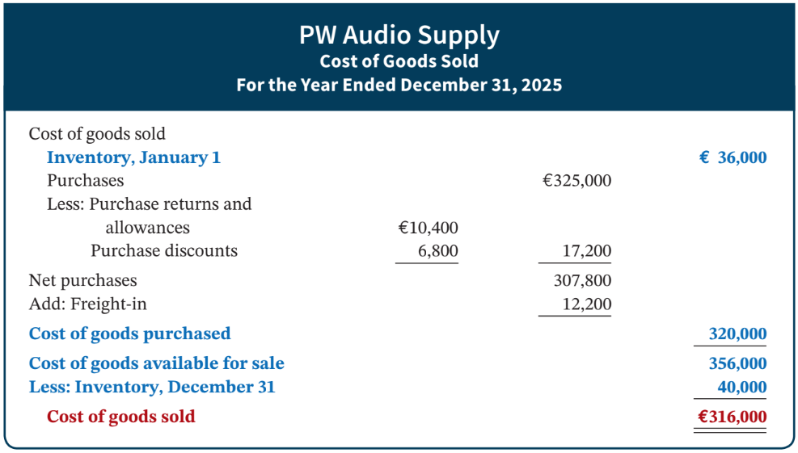



25. **Comparison of Entries—Perpetual vs. Periodic**

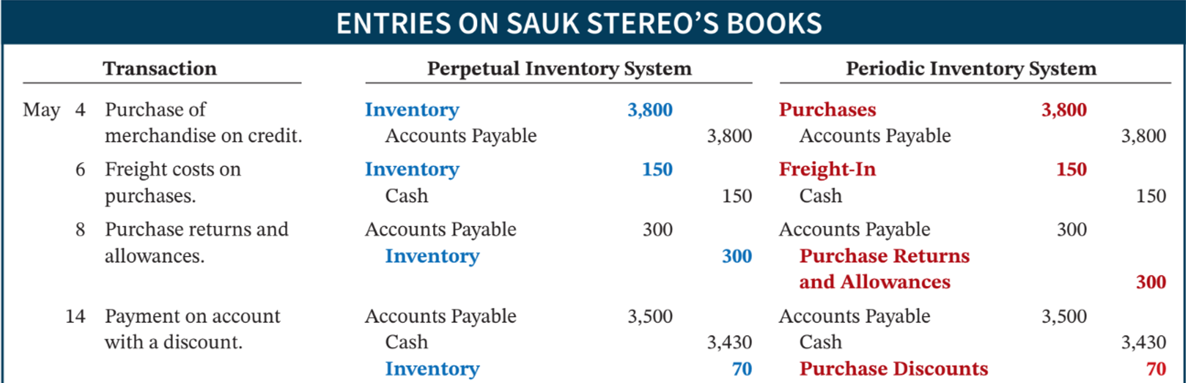 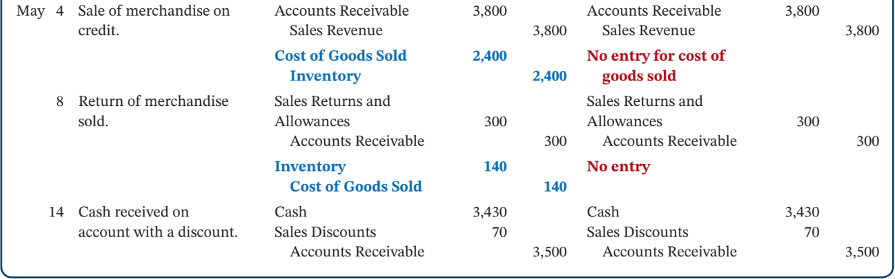

26. **Average-cost** results in lower income taxes (because of lower net income) during times of rising prices.

27. **Inventory turnover** measures the number of times on average the inventory is sold during the period.

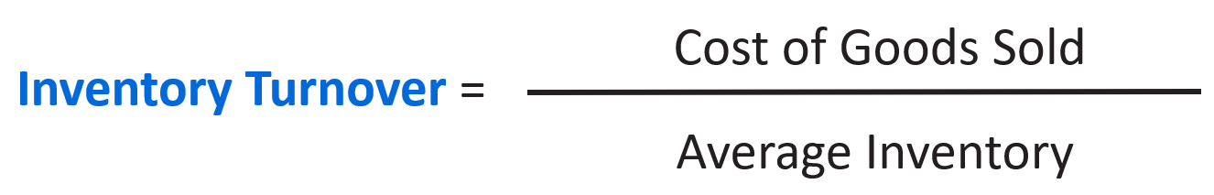



**Days in inventory** measures the average number of days inventory is held.

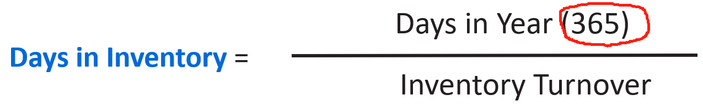

28. Allowance Method for Uncollectible Accounts 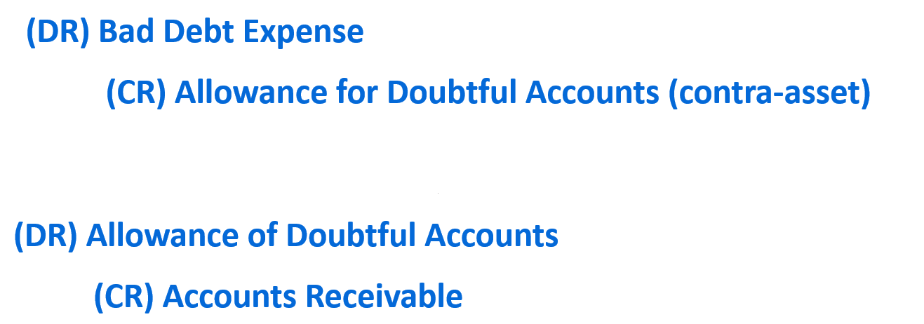



**Recovery of an Uncollectible Account**

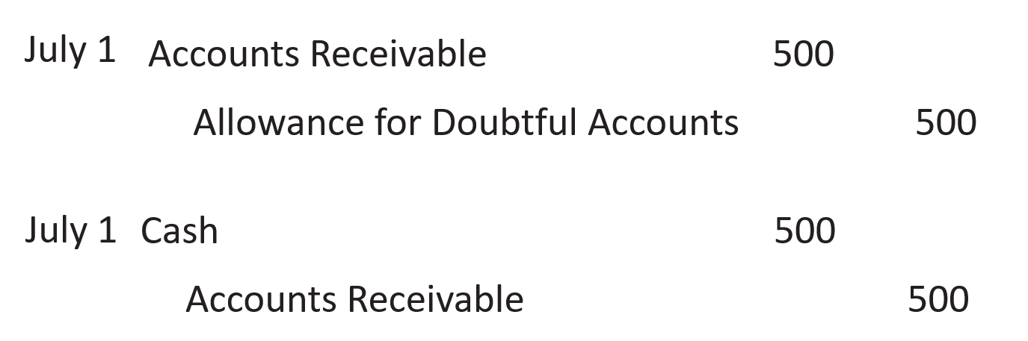

29. **！！！！！！！**

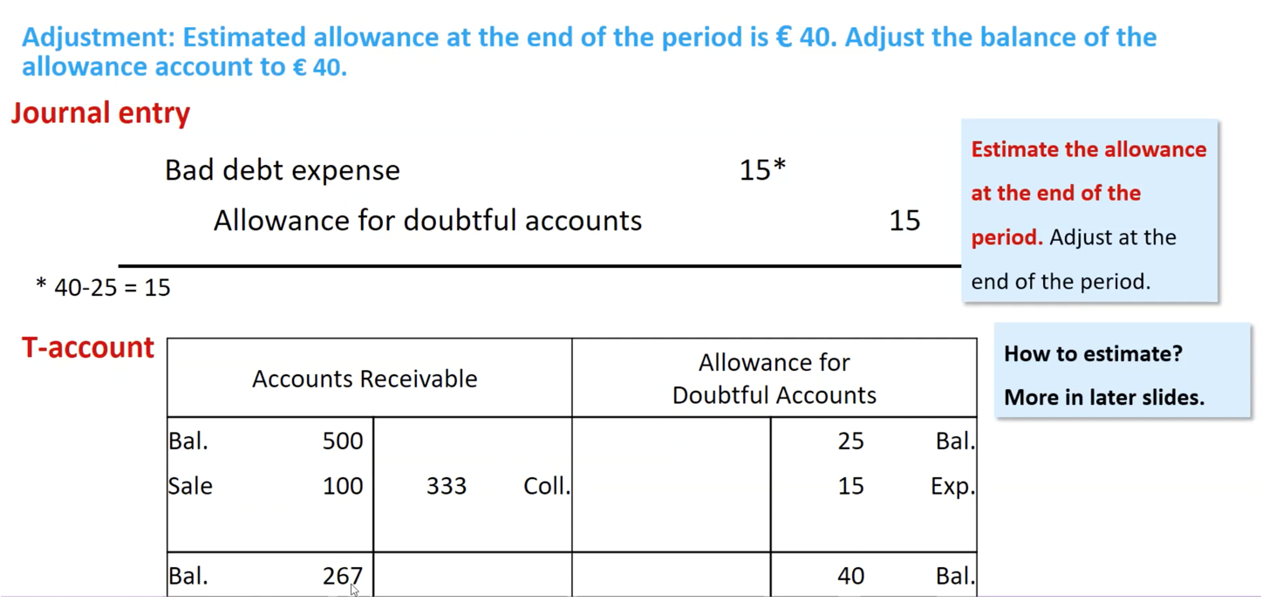

30. **Write-Off**

* A write-off affects **only** statement of financial position accounts.
* It reduces both Accounts Receivable and Allowance for Doubtful Accounts.
* Cash realizable value remains the same.

31. **Disposing (Selling) of Accounts Receivable**

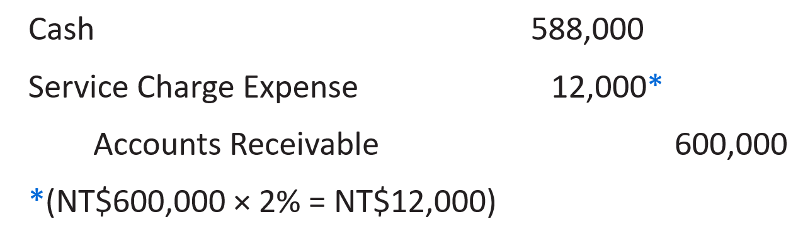



**National Credit Card Sales**

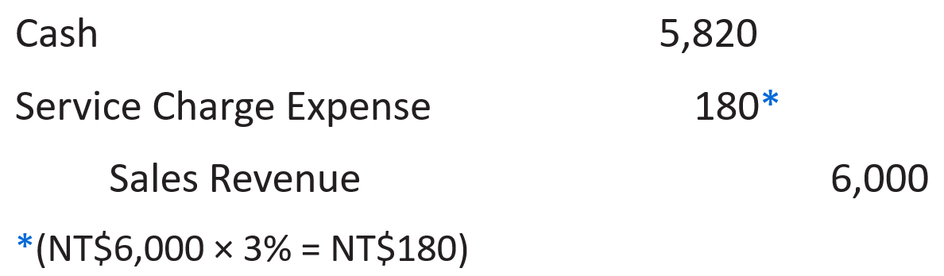

32. **Computing Interest**

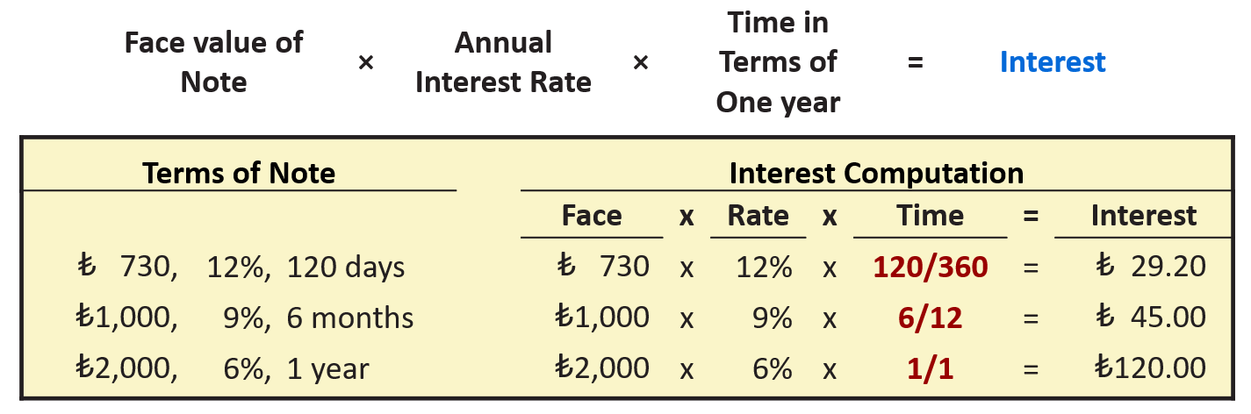

33. **Notes Receivable**

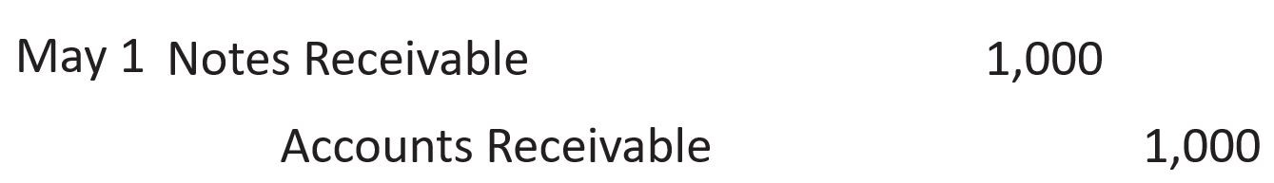 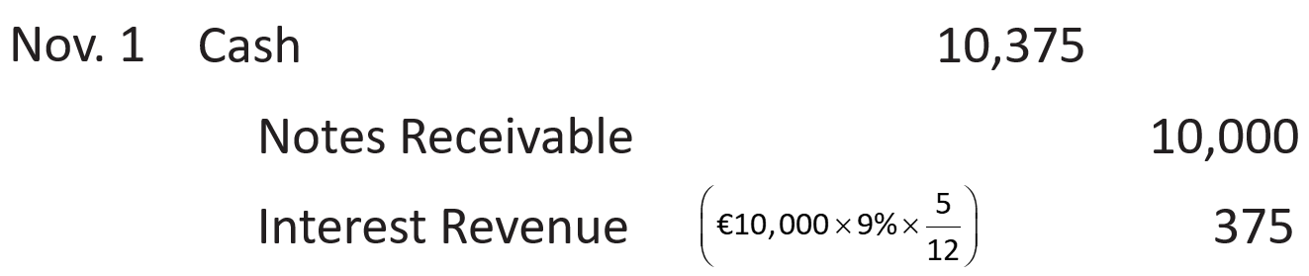



34. **Accrual of Interest Receivable**

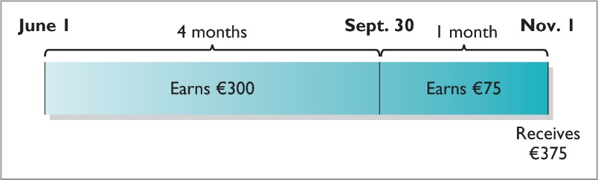



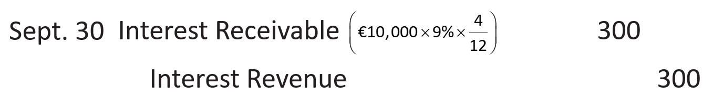 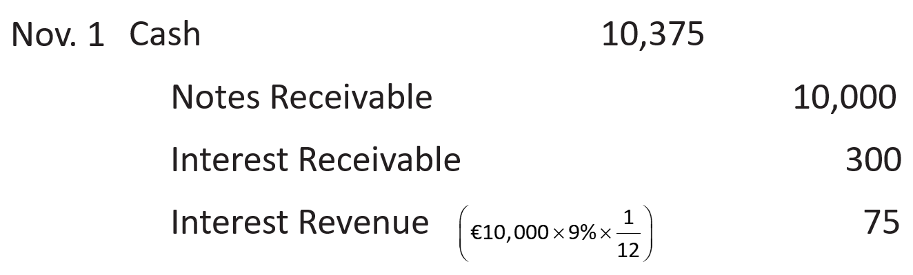



35. **Dishonor of Notes Receivable**

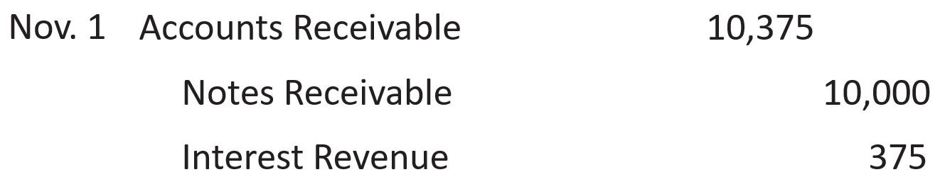 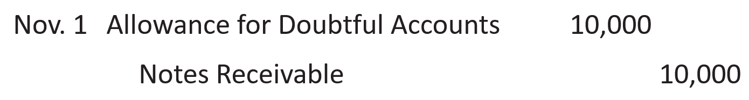



36. 位置

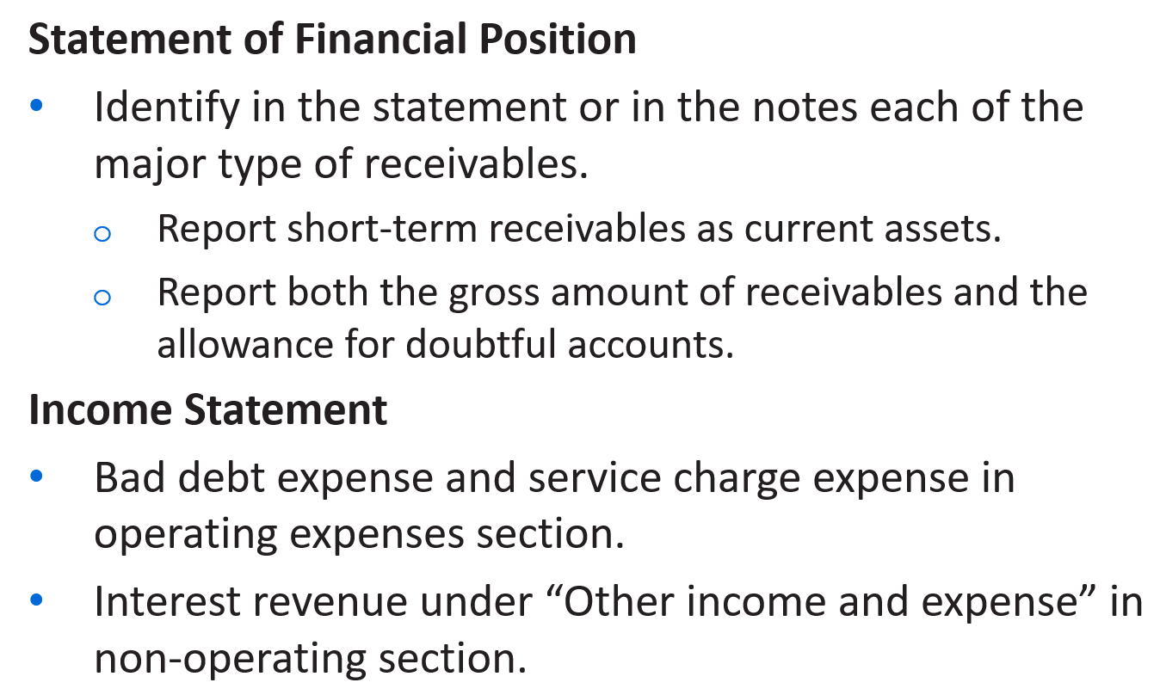

37. AR turnover

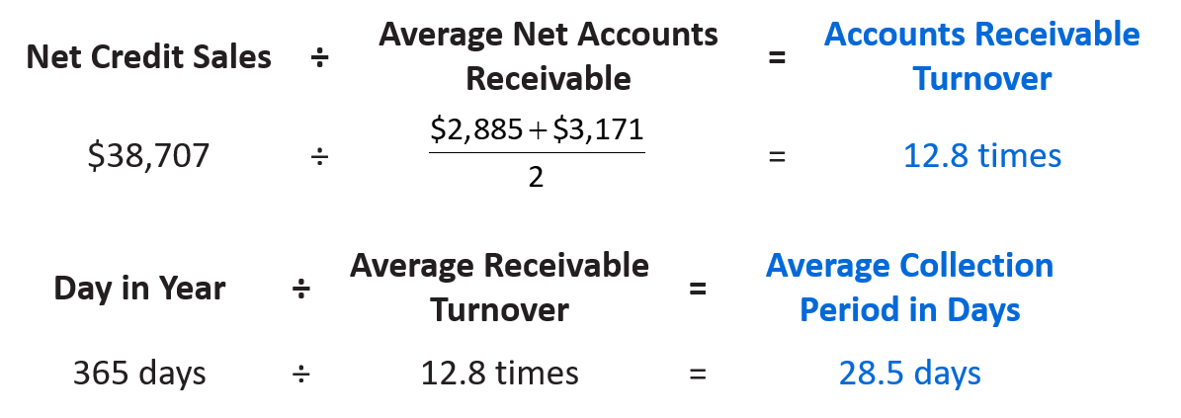



38. **Expenditures During Useful Life**

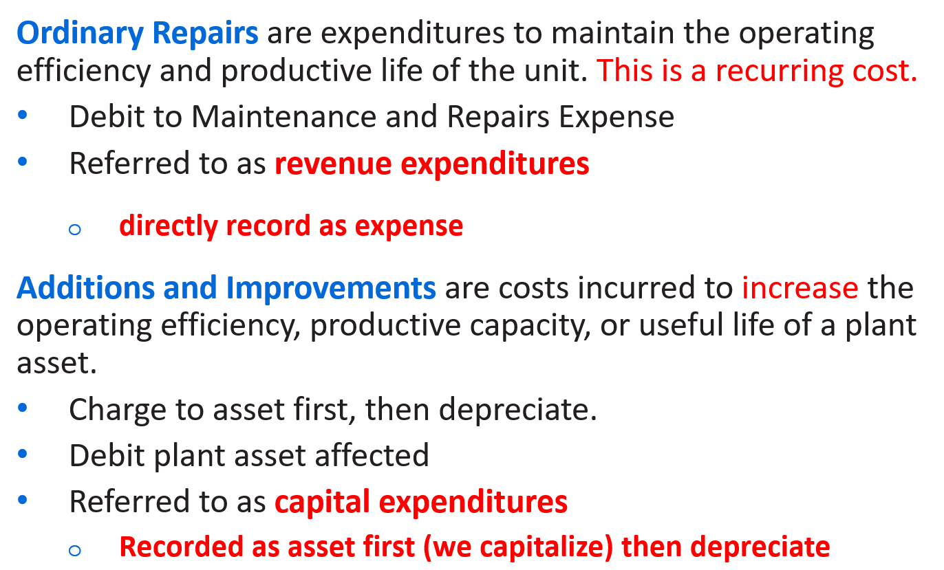

39. Depreciation expense is reported on the income statement.

Accumulated depreciation is reported on the statement of financial position as a deduction from plant assets.

40. **Depreciation**

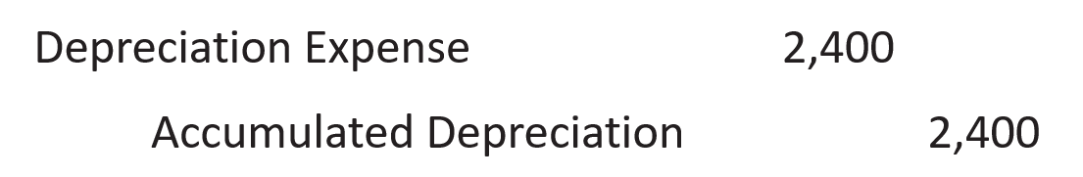

**Revising Periodic Depreciation**

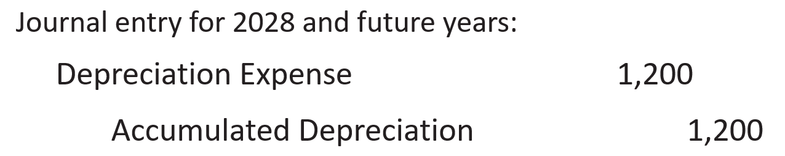

41. **Plant Asset Discarded**

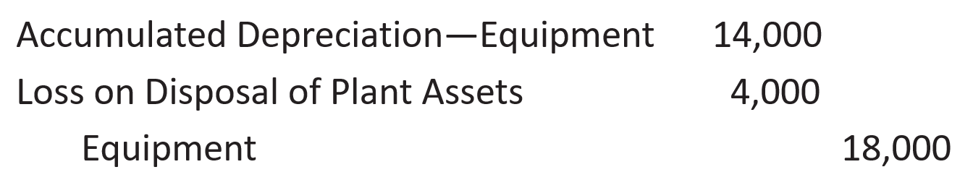

42. **Sale of Plant Assets**

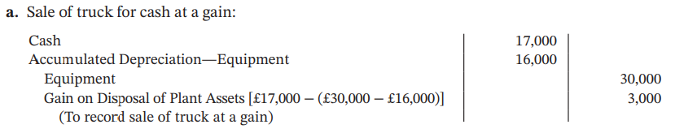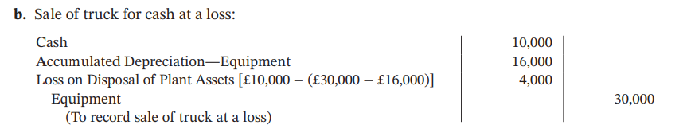

43. **Depletion**

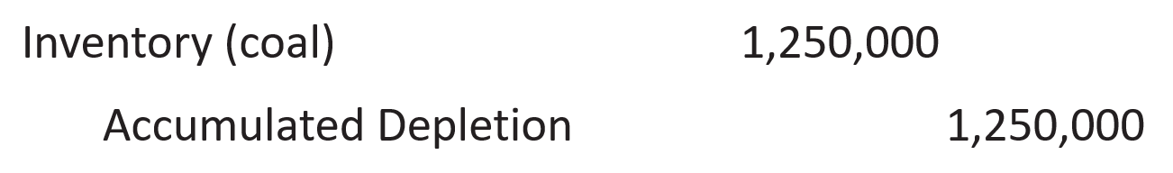

44. **Accounting for Intangible Assets**

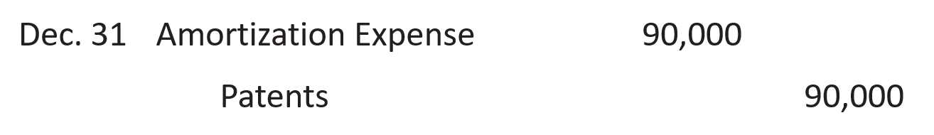

45. 一道错题

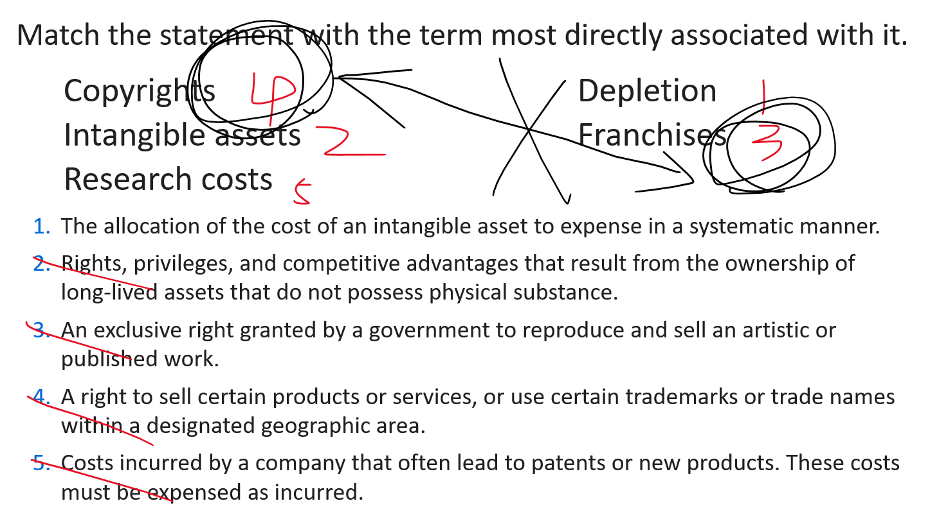

46. **Asset Turnover**

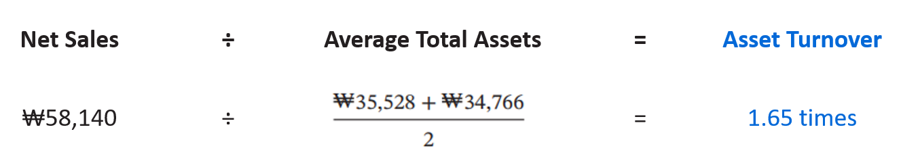



47. **Notes Payable Example**

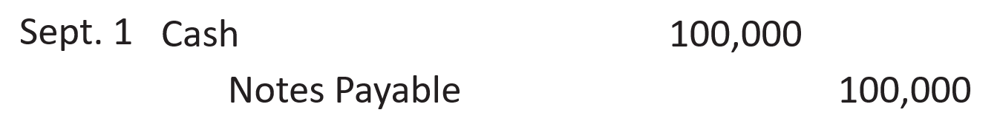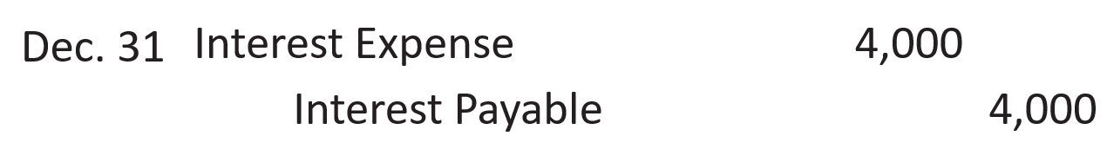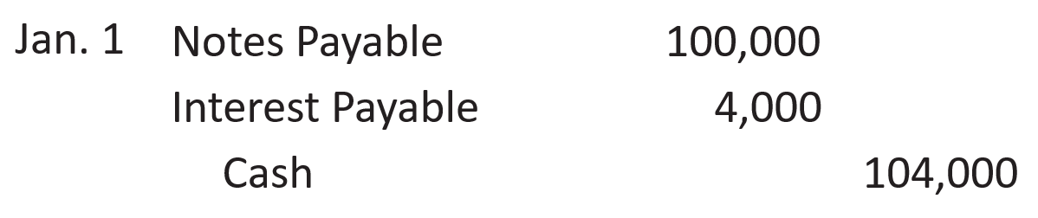

48. **Warranty**

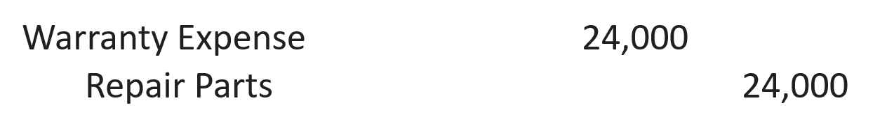

**Adjusting Entry**

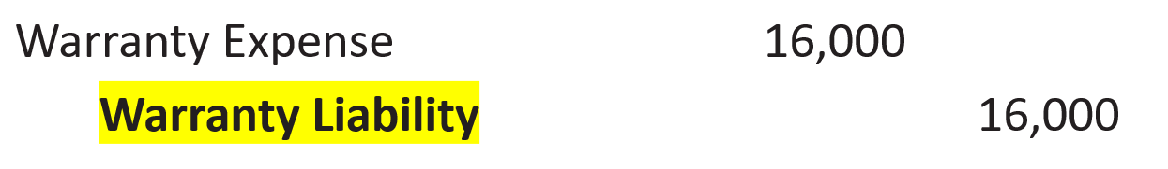

49. **Analysis of Current Liabilities**

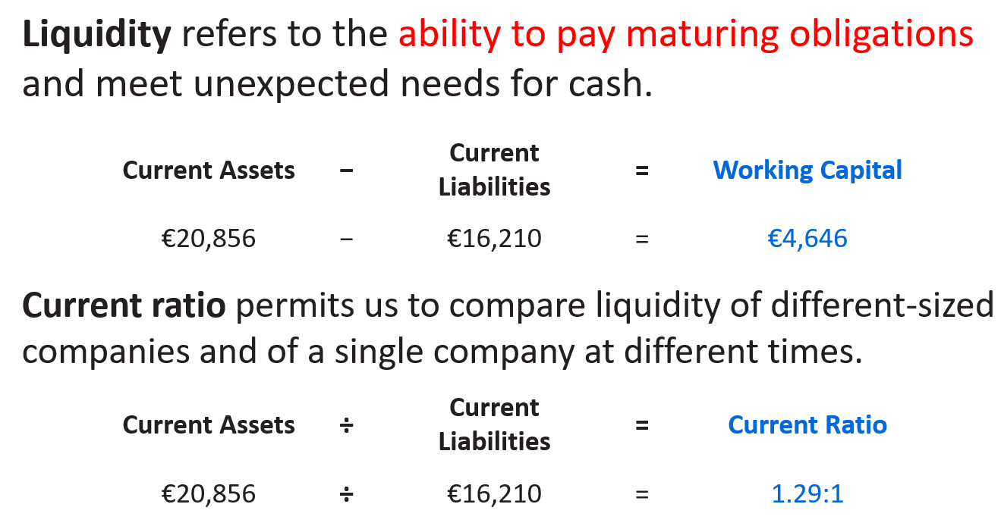



50. **Issuing Bonds**

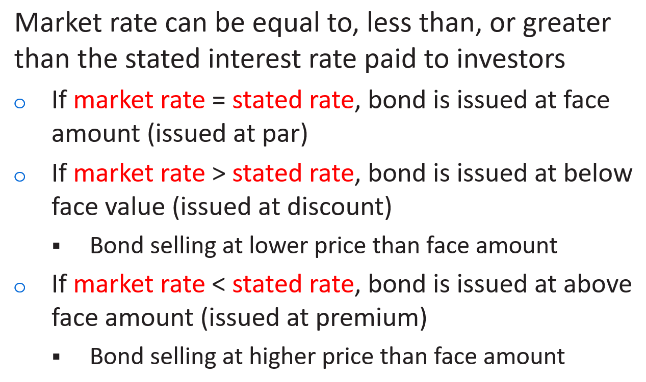

51. **Issuing Bonds at Face Value**

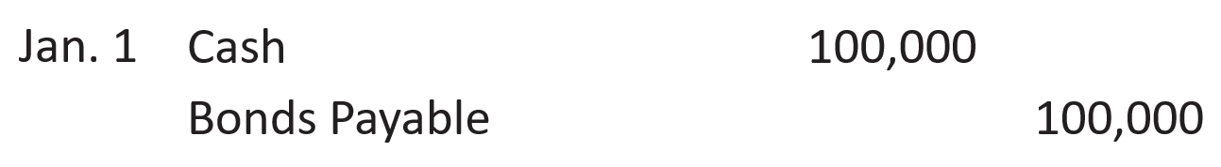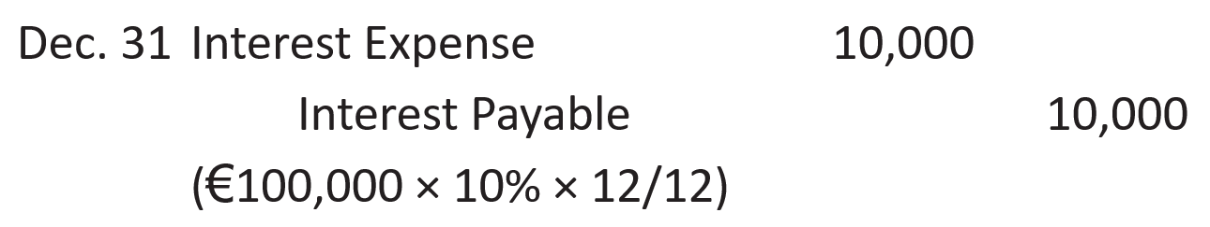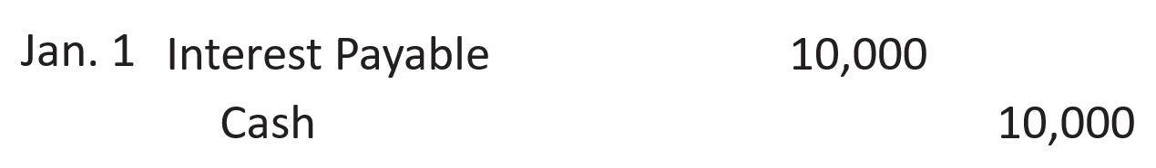

52. **Effective-Interest Method Computation**

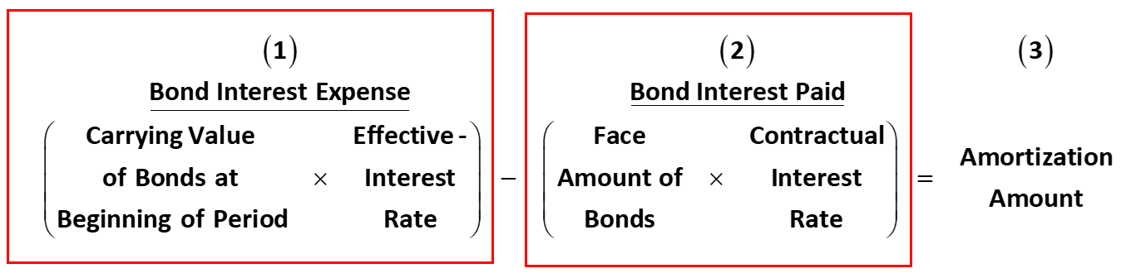

An illustration of a bond discount amortization schedule presents a four-line heading consisting of the name of the company, Candlestick A G; the type of schedule, Bond Discount Amortization Schedule, the method of amortization, Effective-Interest Method—Annual Interest Payments, and the bond issuance information, 10% Bonds Issued at 10.5348%. The schedule has 6 columns which are: Interest periods; A, Interest to Be Paid (10% times Euro 100,000); B, Interest Expense to Be Recorded as (10.5348% times Preceding Bond Carrying Value); C, Discount Amortization is computed as interest expense to be recorded less interest to be paid; D, Unamortized Discount as the previous unamortized discount less the current discount amortization; E, Bond Carrying Value as Euro 100,000 less unamortized discount. The first row is labeled issue date and presents Euro 2,000 in the unamortized discount column and Euro 98,000 in the bond carrying value column. Period 1 presents interest paid, Euro 10,000; Interest expense, Euro 10,324 as 10.5348% times Euro 98,000; Discount amortization, Euro 324; Unamortized discount, 1,676; and bond carrying value, 98,324. Period 2 presents interest paid, Euro 10,000; Interest expense, Euro 10,358, as 10.5348% times Euro 98,324; Discount amortization, Euro 358; Unamortized discount, 1,318; and bond carrying value, 98,682. Period 3 presents interest paid, Euro 10,000; Interest expense, Euro 10,396, as 10.5348% times Euro 98,682; Discount amortization, Euro 396; Unamortized discount, 922; and bond carrying value, 99,078. Period 4 presents interest paid, Euro 10,000; Interest expense, Euro 10,438, as 10.5348% times Euro 99,078; Discount amortization, Euro 438; Unamortized discount, 484; and carrying value, 99,516. Period 5 presents interest paid, Euro 10,000; Interest expense, Euro 10,484, as 10.5348% times Euro 99,516; Discount amortization, Euro 484; Unamortized discount, 0; and bond carrying value, 100,000. The total of interest paid is Euro 50,000. The total of interest expense is Euro 52,000. The total of discount amortization is Euro 2,000.A note at the bottom of the table reads: Column (A) remains constant because the face value of the bonds (Euro 100,000) is multiplied by the annual contractual interest rate (10%) each period. Column (B) is computed as the preceding bond carrying value times the annual effective-interest rate (10.5348%).Column (C) indicates the discount amortization each period. Column (D) decreases each period until it reaches zero at maturity. Column (E) increases each period until it equals face value at maturity. 

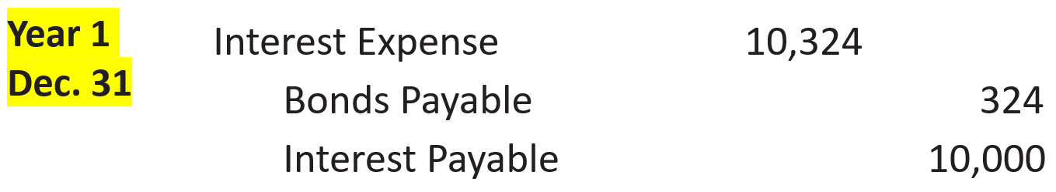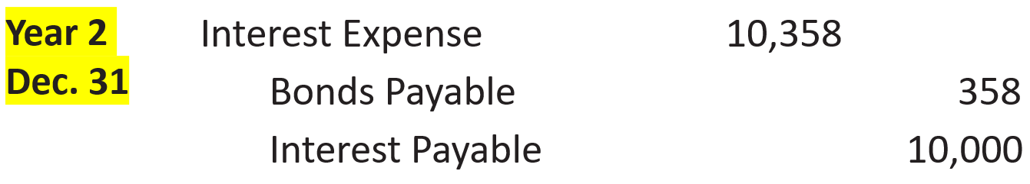

An illustration of a bond premium amortization schedule displays a four-line heading consisting of the name of the company, Candlestick A G; the type of schedule, Bond Premium Amortization Schedule, the method of amortization, Effective-Interest Method—Annual Interest Payments, and the bond issuance information, 10%  Bonds Issued at 9.4794%  Effective-Interest Rate. The schedule has 6 columns which are: Interest Periods; A, Interest to Be Paid (10% times Euro 100,000), Interest Expense to Be Recorded (9.4794% times Preceding Bond Carrying Value); Premium Amortization as interest expense less interest to be paid; Unamortized Premium as the previous period’s unamortized premium less the current period amortization; Bond Carrying Value (Euro 100,000 plus the unamortized premium). The first row is labeled as issue date and presents Euro 2,000 in the unamortized premium column and Euro 102,000 in the bond carrying value column. Period 1 presents interest paid, Euro 10,000; Interest expense, Euro 9,669, as 9.4794% times Euro 102,000; Premium amortization, Euro 331; Unamortized premium, 1,669; and bond carrying value, 101,669. Period 2 presents interest paid, Euro 10,000; Interest expense, Euro 9,638, as 9.4794% times Euro 101,669; Premium amortization, Euro 362; Unamortized premium, 1,307; and bond carrying value, 101,307. Period 3 presents interest paid, Euro 10,000; Interest expense, Euro 9,603, as 9.4794% times Euro 101,307; Premium amortization, Euro 397; Unamortized premium, 910; and carrying value, 100,910. Period 4 presents interest paid, Euro 10,000; Interest expense, Euro 9,566, as 9.4794% times Euro 100,910; Premium amortization, Euro 434; Unamortized premium, 476; and bond carrying value, 100,476. Period 5 shows interest paid, Euro 10,000; Interest expense, Euro 9,524 asterisk, as 9.4794% times Euro 100,476; Premium amortization, Euro 476 asterisk; Unamortized premium, 0; and carrying value, 100,000. The total of interest paid is Euro 50,000. The total of interest expense is Euro 48,000. The total of premium amortization is Euro 2,000.A note at the bottom of the table reads: Column (A) remains constant because the face value of the bonds (Euro 100,000) is multiplied by the contractual interest rate (10%) each period. Column (B) is computed as the carrying value of the bonds times the annual effective-interest rate (9.4794%).Column (C) indicates the premium amortization each period. Column (D) decreases each period until it reaches zero at maturity. Column (E) decreases each period until it equals face value at maturity. Asterisk stands for, Rounded to eliminate remaining premium resulting from rounding the effective rate. 

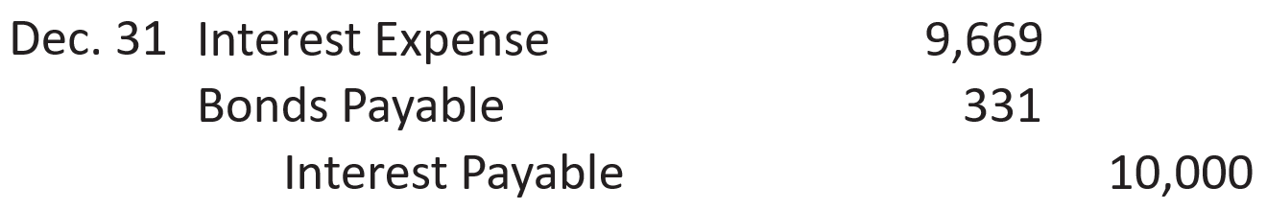

53. **Redeeming before Maturity**

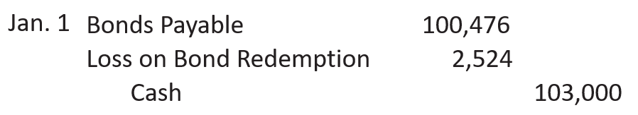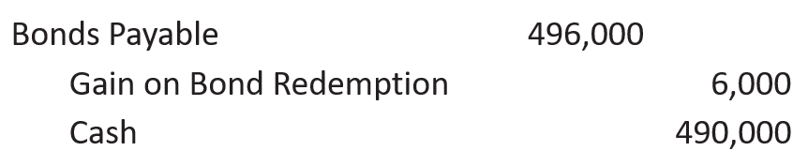

54. **Long-Term Notes Payable**

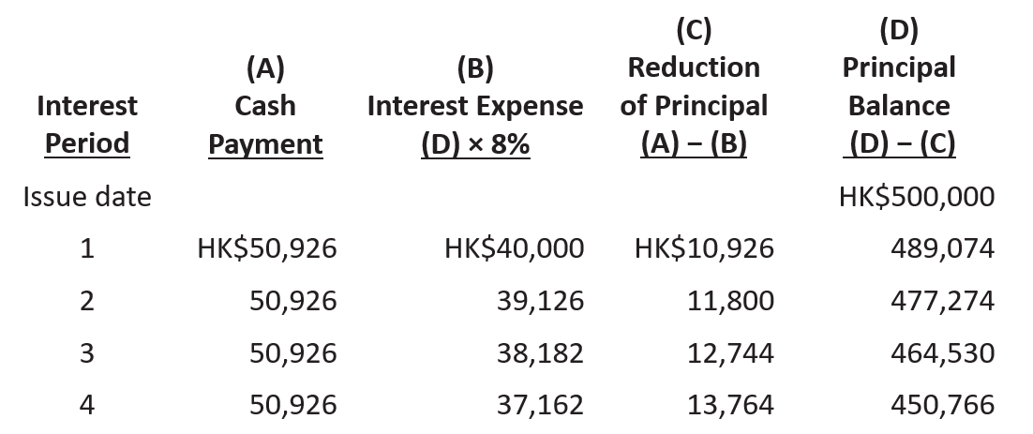

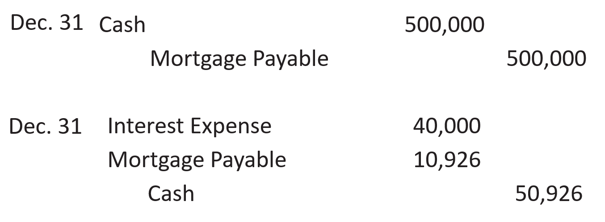

55. Debt to Assets Ratio / Times Interest Earned Ratio

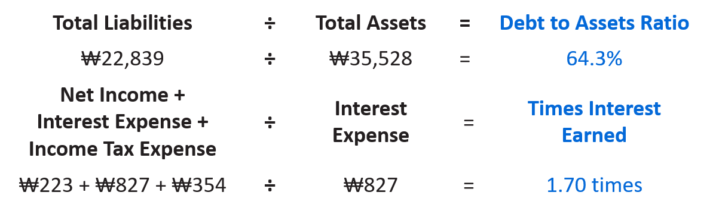



56. **Issuing par value ordinary shares for cash** (cash——Organization expense/land)

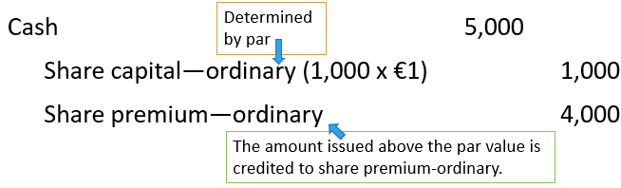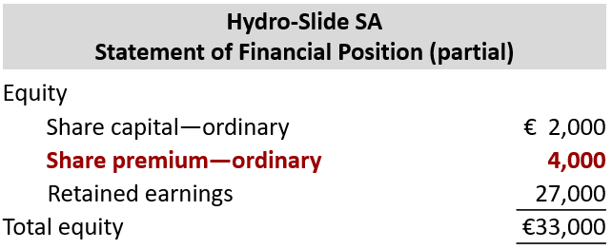

57. **Purchase of treasury shares**

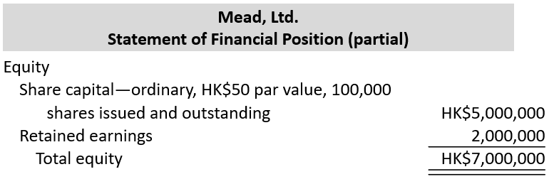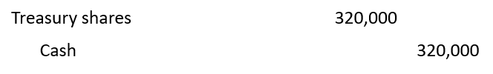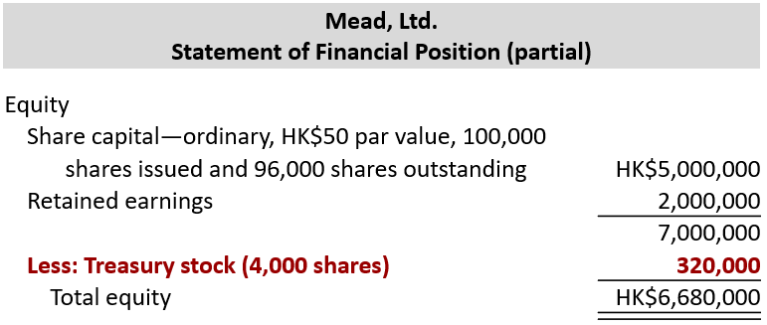

58. **Sale of treasury shares**

**above cost**

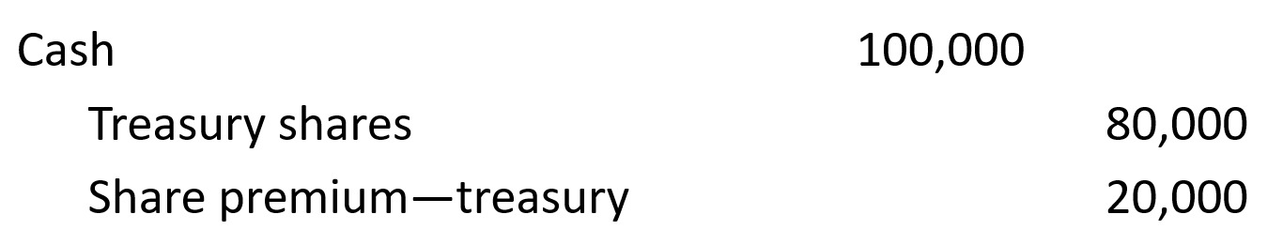

**below cost**

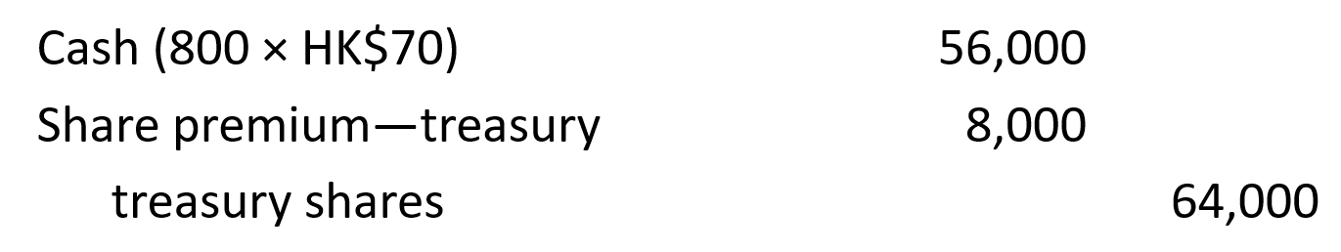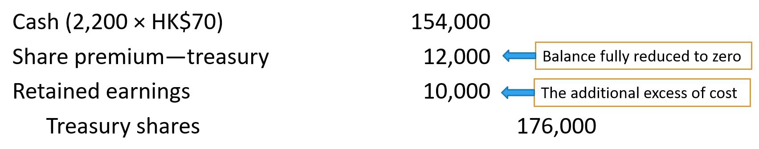

59. **Accounting for cash dividends**

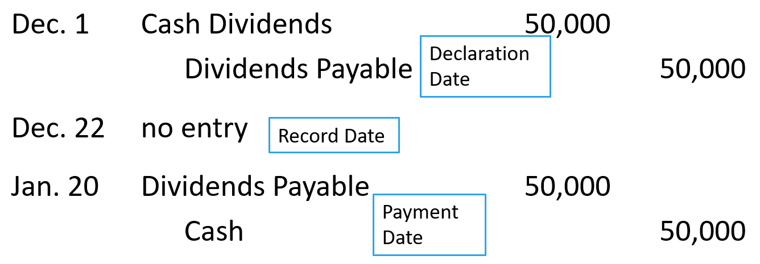

60. **Dividend preferences**

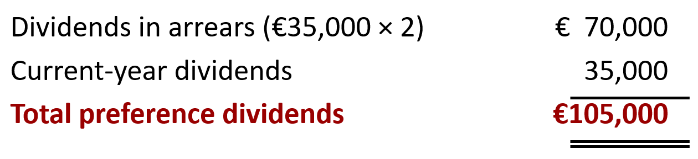

61. **Accounting for share dividends**

- Small share dividend (less than 20–25% of corporation’s issued shares, recorded at fair market value)

- Large share dividend (greater than 20–25% of issued share, recorded at par value, not covered)

62. **Entries for share dividends**

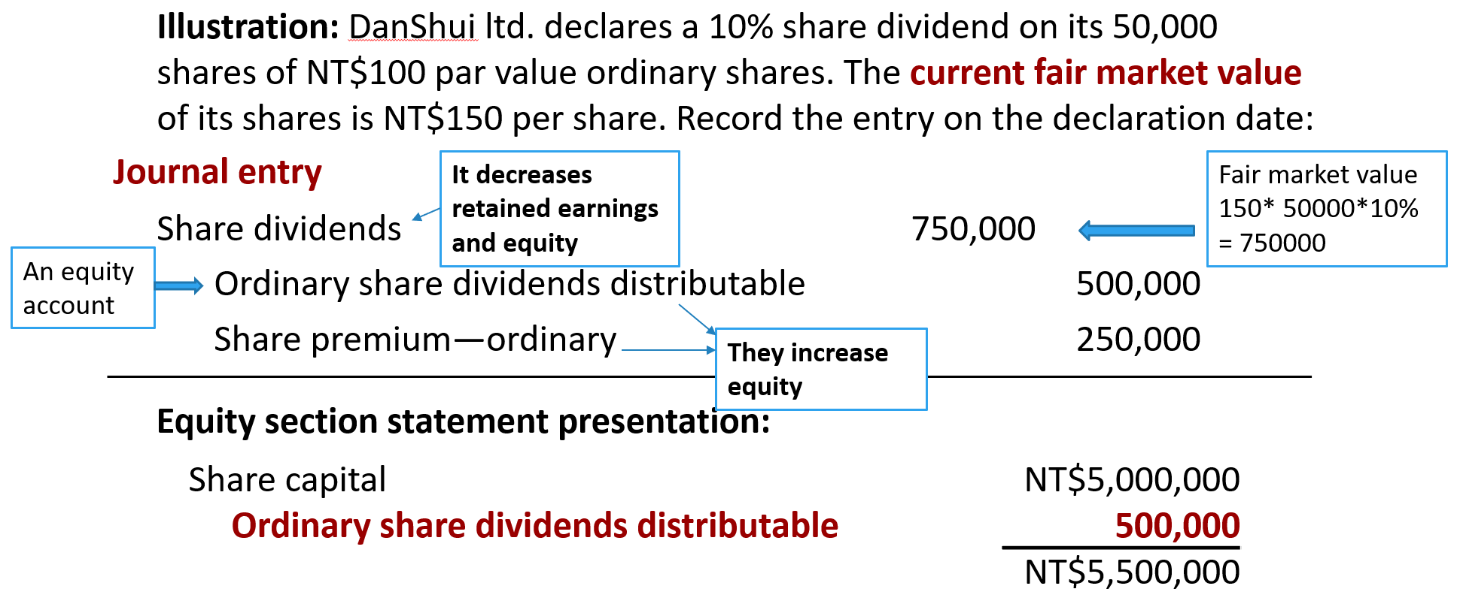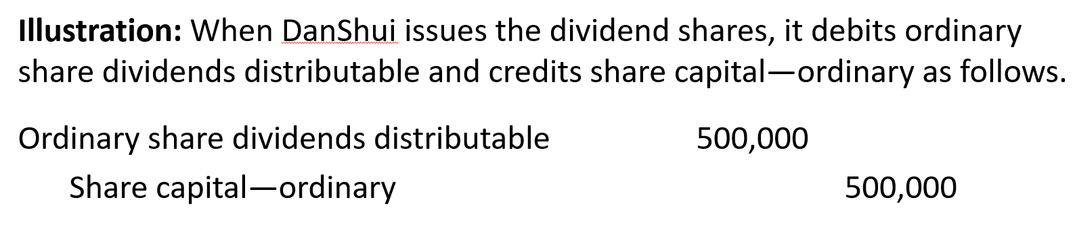

63. **Effects of share dividends:** Transfers a portion of retained earnings to share capital and share premium. No change on total equity. No effect on the par or stated value per share. Total number of outstanding shares increases.

64. **Differences between the effects of share dividends and share splits**

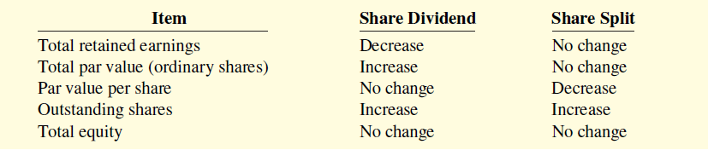

65. 一道例题！！！

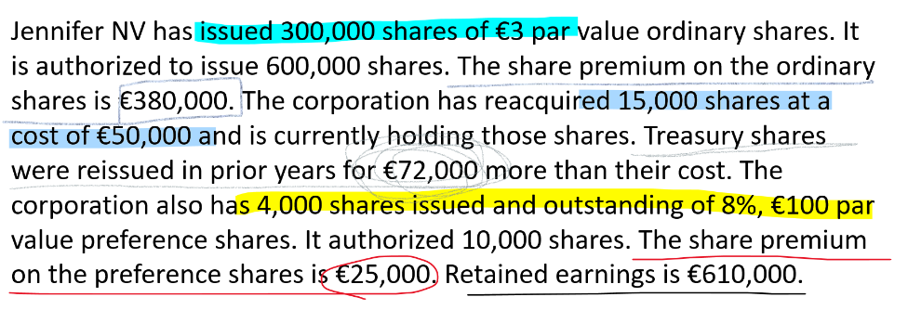

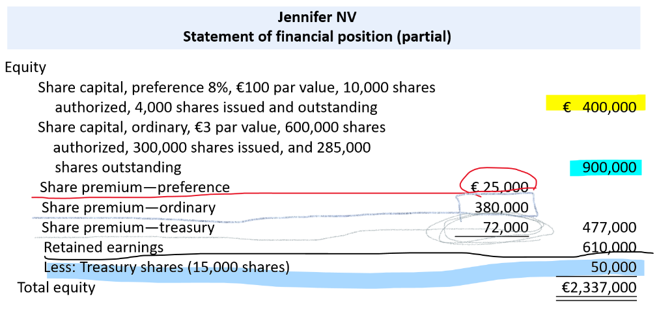

66. **Return on ordinary shareholders’ equity**

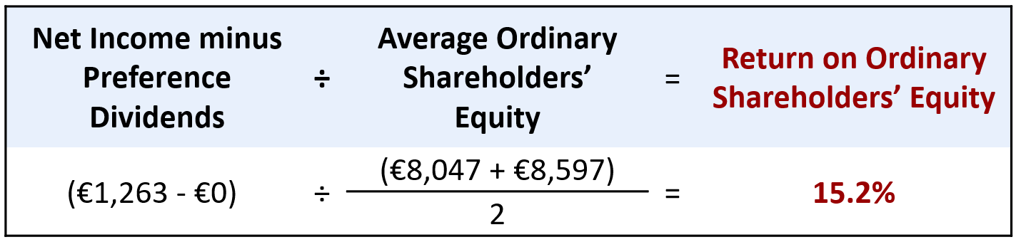

67. **Classification of Cash Flows**

**Operating activities**—Income statement items

**Cash inflows:**

From sale of goods or services.

From interest received and dividends received.



**Cash outflows:**

To suppliers for inventory.

To employees for wages.

To government for taxes.

To lenders for interest.

To others for expenses.

**Investing activities—**Changes in investments and non-current assets

**Cash inflows:**

From sale of property, plant, and equipment.

From sale of investments in debt or equity securities of other entities.

From collection of principal on loans to other entities.

**Cash outflows:**

To purchase property, plant, and equipment.

To purchase investments in debt or equity securities of other entities.

To make loans to other entities.

**Financing activities—**Changes in non-current liabilities and equity

**Cash inflows:**

From sale of ordinary shares.

From issuance of long-debt (bonds and notes).

**Cash outflows:**

To shareholders as dividends.



To redeem long-term debt or reacquire

ordinary shares (treasury shares).

68. **Summary of Conversion to Net Cash Provided by Operating Activities—Indirect Method**

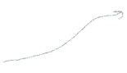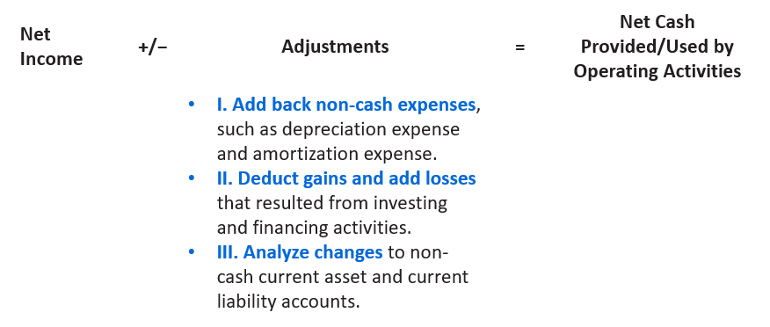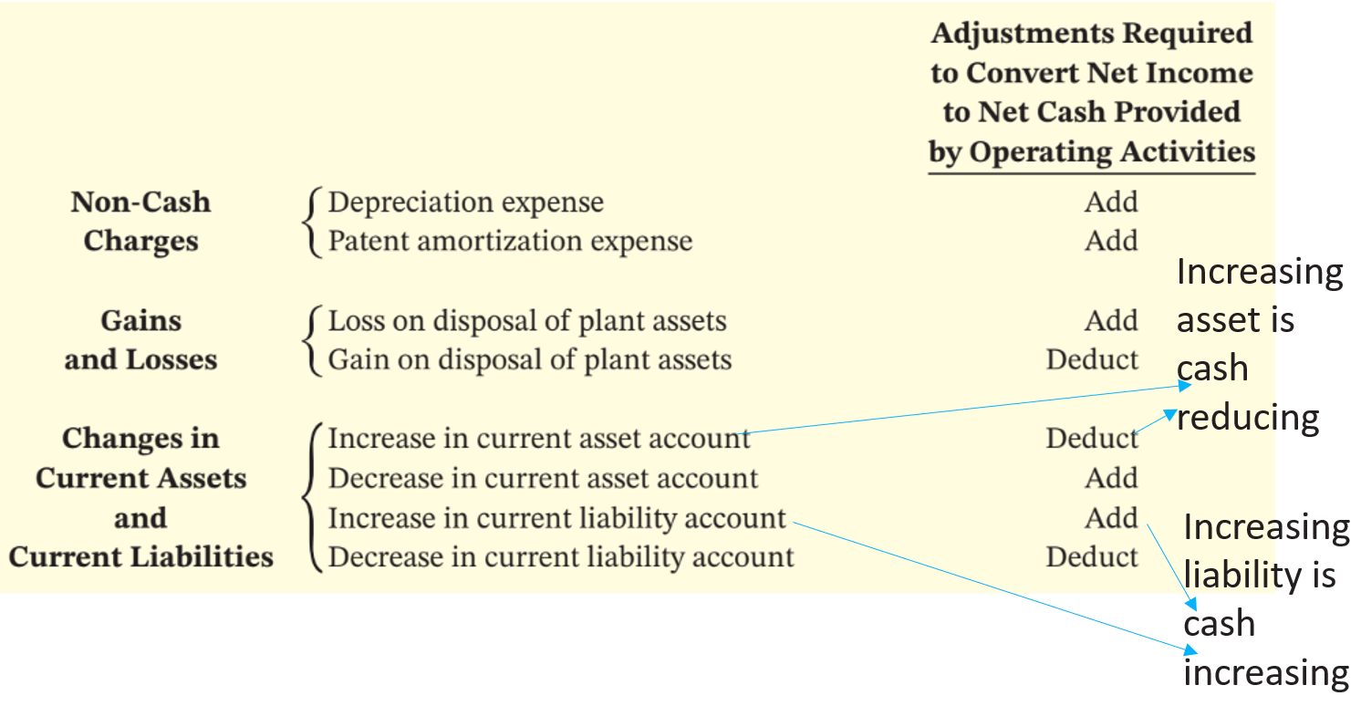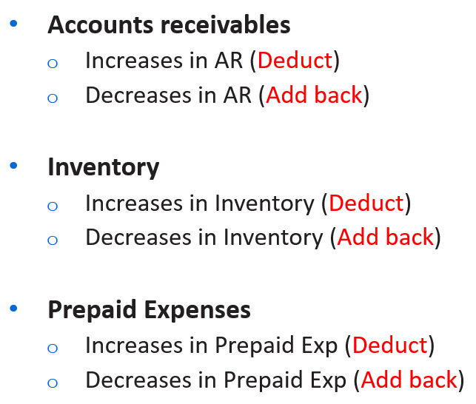



69. 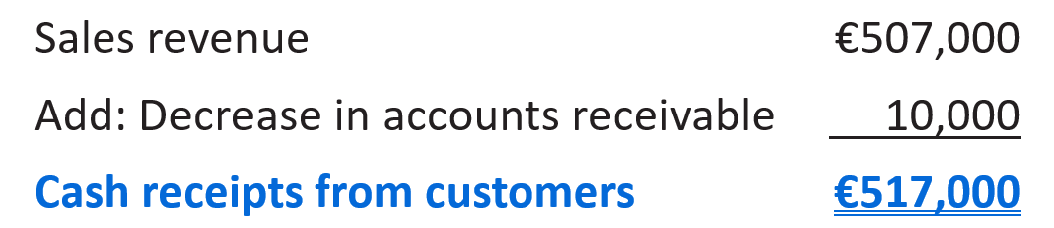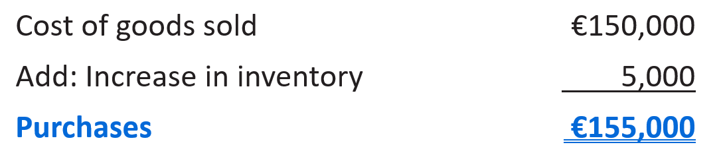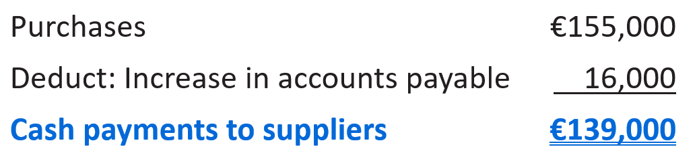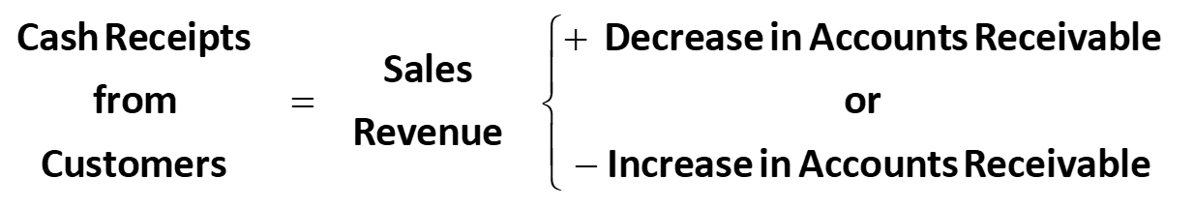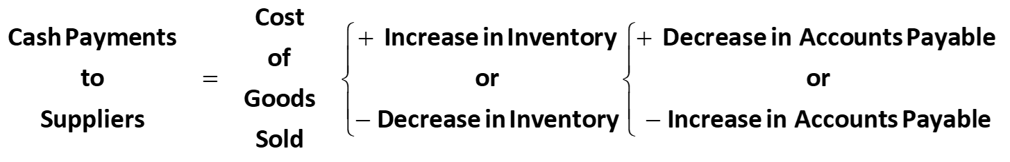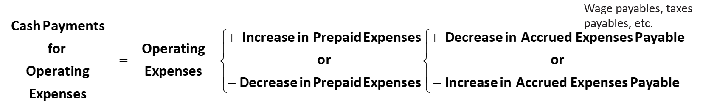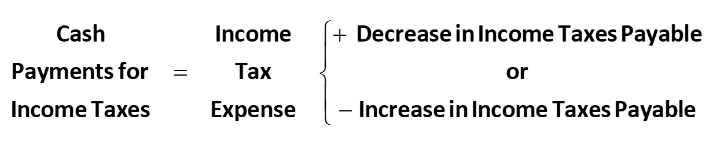

70. **Free Cash Flow (FCF)**

71. **Summary of Ratios**

